**NAMA : IRVIANTO CATUR SAPUTRA 1801388531**

**ADJI SAKA PRAYUDA 2101636734**

**SPLASH SCREEN**

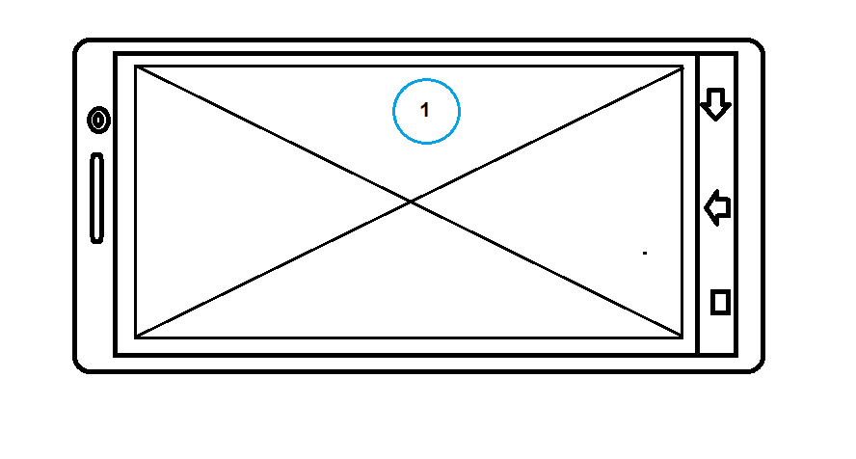

1. **LOGO GAME**

**LOADING**

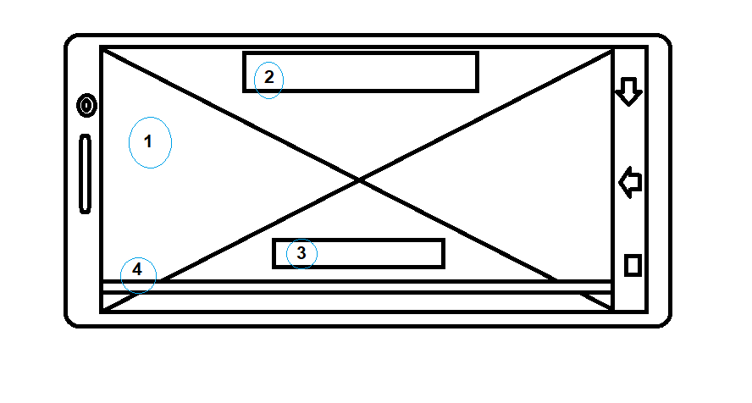

1. **IMAGE GAME/ EVENT**
2. **GAME NAME**
3. **NOTIF/ PEMBERITAHUAN**
4. **LOADING BAR**

**LOGIN**

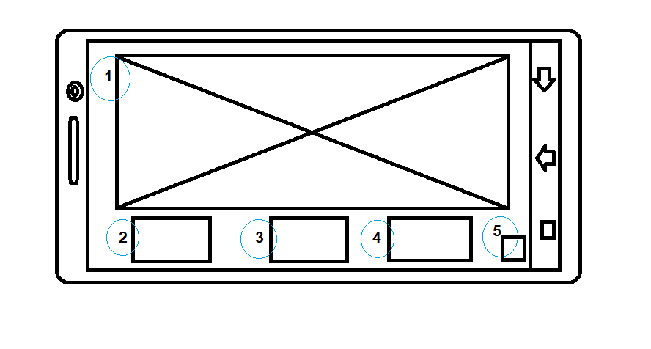

1. **IMAGE GAME/EVENT**
2. **LOGIN GOOGLE ACCCOUNT**
3. **LOGIN FACEBOOK ACCOUNT**
4. **LOGIN GUEST**
5. **QUIT GAME**

**MAIN MENU**

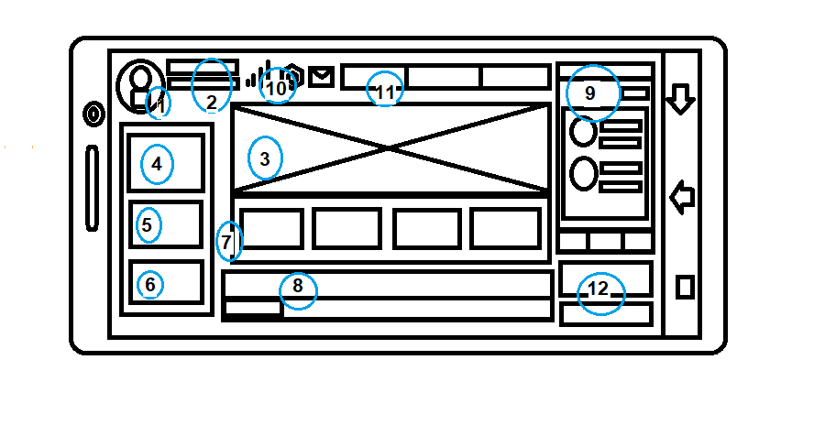

1. **FOTO PROFILE**
2. **NAME AND LEVEL**
3. **GAME IMAGE/EVENT**
4. **SHOP**
5. **IVENTORY**
6. **CLAN**
7. **CHOICE MATCH**
8. **CHAT**
9. **FRIEND LIST**
10. **SETTING, MESSAGE, SINYAL**
11. **MONEY**
12. **GIFT EVENT**

**SHOP**

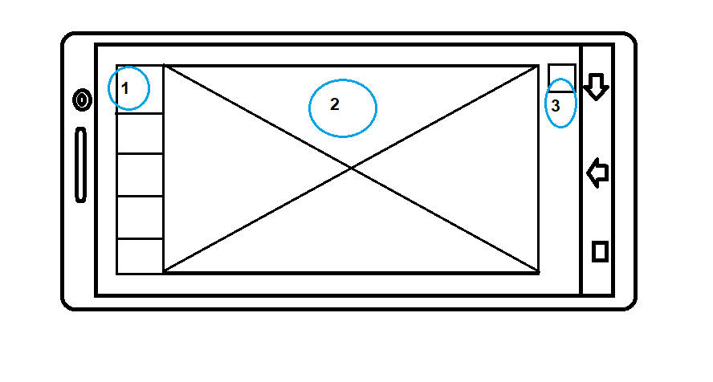

1. **LIST ITEM HERO DSB**
2. **DETAIL ITEM HERO DSB**
3. **BACK**

**OPTION**

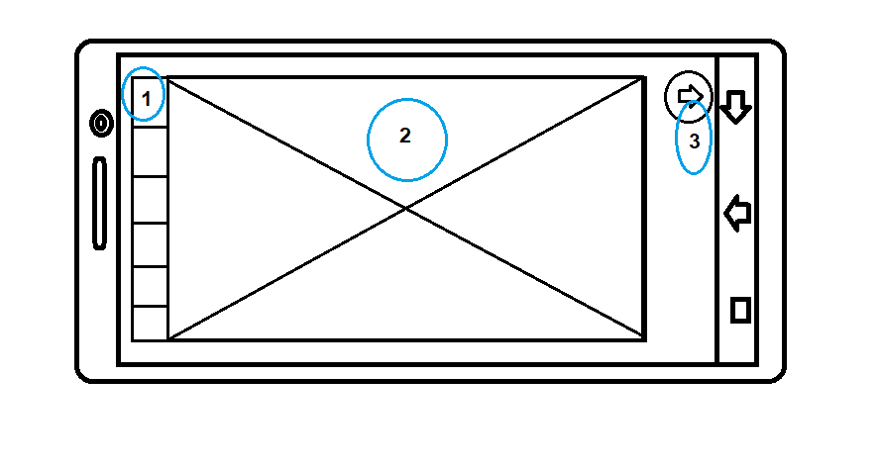

1. **LIST OPTION**
2. **DETAIL OPTION**
3. **BACK**

**FRIEND**

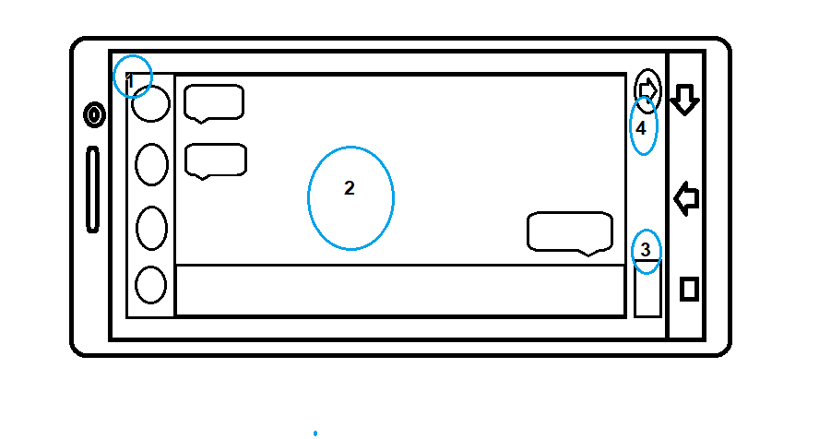

1. **LIST FRIEND**
2. **CHAT**
3. **FRIEND REQUEST**
4. **BACK**

**MESSAGE/REWARD**

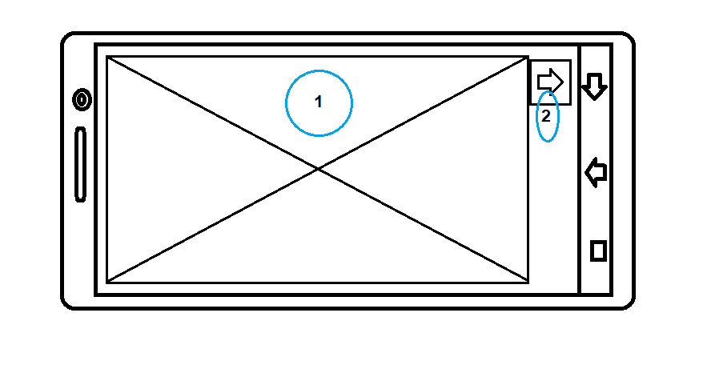

1. **MESSAGE/REWARD**
2. **BACK**

**INVENTORY**

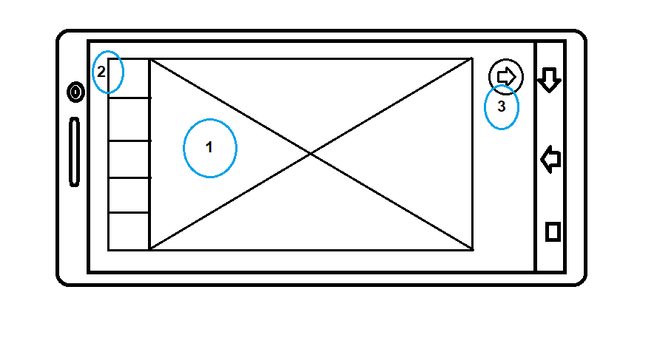

1. **DETAIL INVENTORY**
2. **LIST INVENTORY**
3. **BACK**

**PREMATCH**

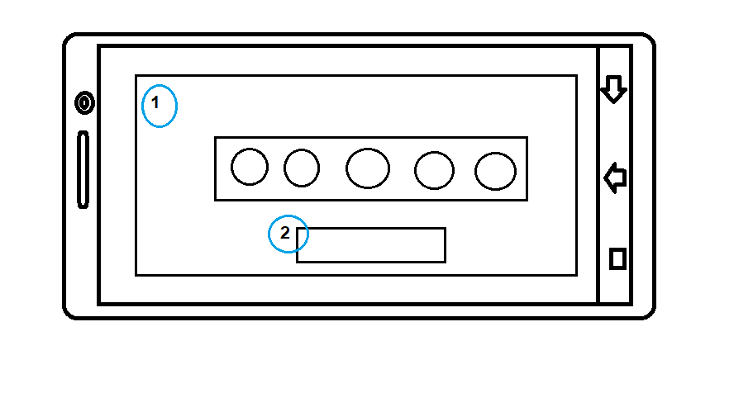

1. **IMAGE GAME DAN LIST PLAYER**
2. **READY BUTTON**

**PICK HERO**

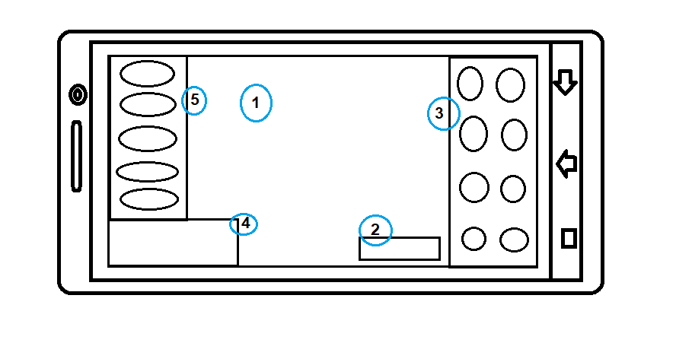

1. **IMAGE/3D HERO**
2. **READY BUTTON**
3. **LIST HERO**
4. **CHAT**
5. **TEAM**

**LOADING MATCH**

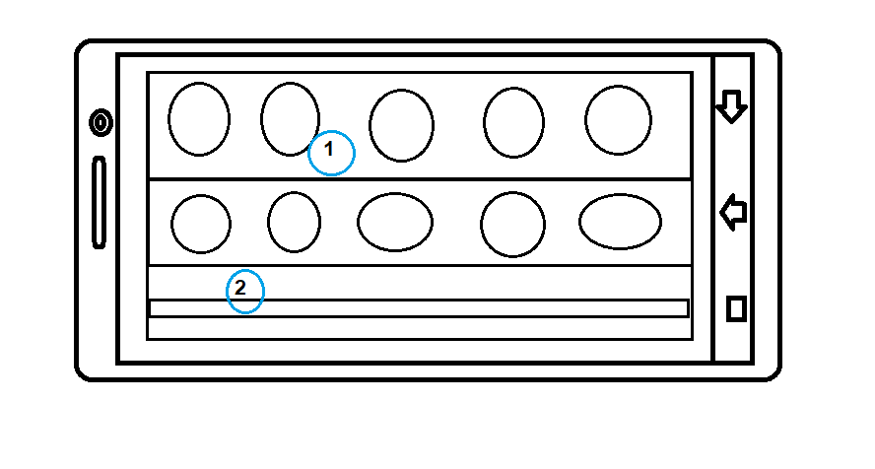

1. **TEAM AND OPPONENT**
2. **LOADING BAR**

**END GAME**

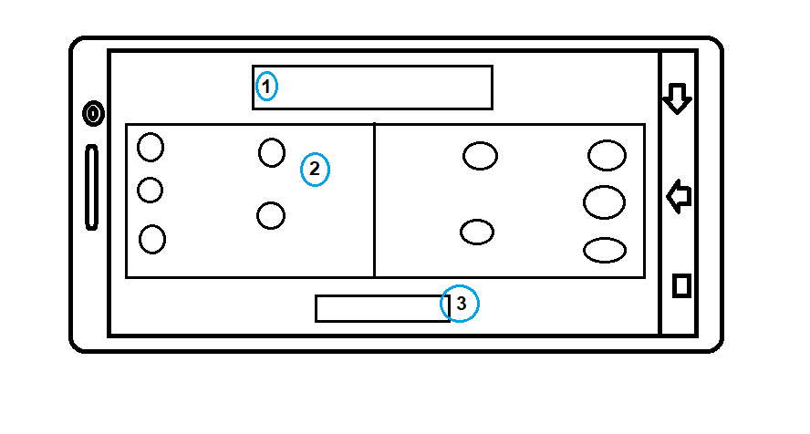

1. **VICTORY/LOSS**
2. **TEAM AND OPPONENT SCORE**
3. **BACK LOBBY**

**GAMEPLAY**

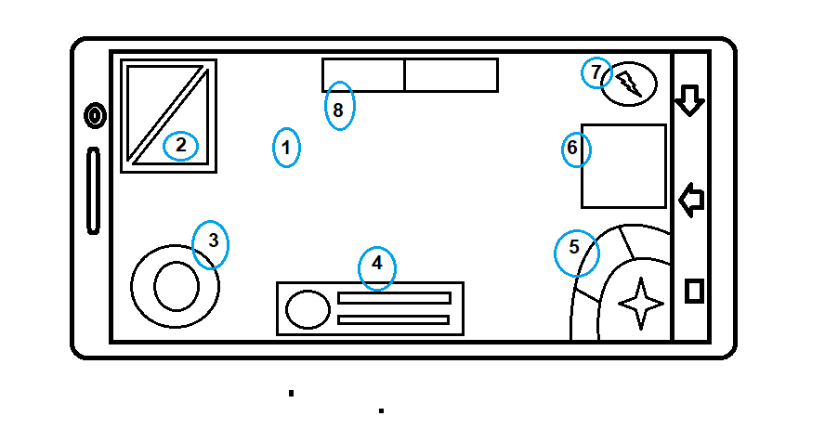

1. **GAME MATCH**
2. **MINI MAP**
3. **ANALOG/CONTROLER**
4. **STATUS HERO, HP AND SP**
5. **ATTACK AND SKILL**
6. **CHAT**
7. **SHOP IN GAME**

**CLAN**

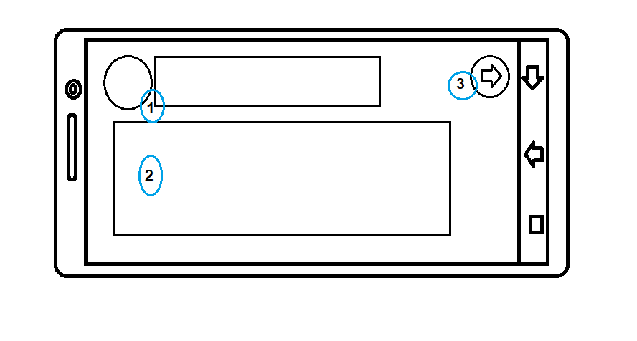

1. **DETAIL CLAN**
2. **MEMBER CLAN**
3. **BACK**